PROJECT OVERSEAS 2024
Project Overseas (PO) is a joint endeavour of the Canadian Teachers’ Federation (CTF/FCE) and its Member and Associate Organizations to support partners in developing countries as they co-plan and co-deliver professional learning to local teachers. Since 1962, PO has assisted teacher organizations in over 50 countries in Africa, Asia and the Pacific, and the Caribbean. Every July, PO places over 50 volunteers in 10 to 15 countries. Financial support is provided by the CTF/FCE and its Member Organizations.

MAIN OBJECTIVES OF THE PROGRAM
PO is a key part of the CTF/FCE’s International and Social Justice Program. It focuses on teachers taking action for:
- Teaching — Canadian teachers work with overseas colleagues to co-plan and co-facilitate workshops for teachers and education workers.
- Teacher Organizations — The program assists Partner Organizations overseas as they strengthen their capacities to provide professional services to their members.
- Gender Equality — The program addresses gender equality for students and teachers, assists in the development of gender-responsive school environments, and works to build awareness around school-related gender-based violence.
PO is often an integral part of long term projects that strengthen and promote equitable, high quality, publicly-funded education for all.

TERMS OF THE ASSIGNMENT
Participants:
- will be assigned to a location where there is a CTF/FCE project but will not choose their location;
- must be available for an assignment during the month of July and for preparation leading up to the assignment;
- will be part of a team, which has a designated team leader;
- usually share living accommodations with other PO participants;
- do not receive payment for the assignment, however travel and basic living expenses are covered;
- cannot be accompanied by family members and friends.

SELECTION OF PARTICIPANTS
Applications are received and reviewed by the CTF/FCE Member Organizations before the selected applications are forwarded to the CTF/FCE. Participants are chosen on the basis of advice from Member Organizations and the expressed needs of the Partner Organizations overseas. Successful applicants are notified of their assignments in February.
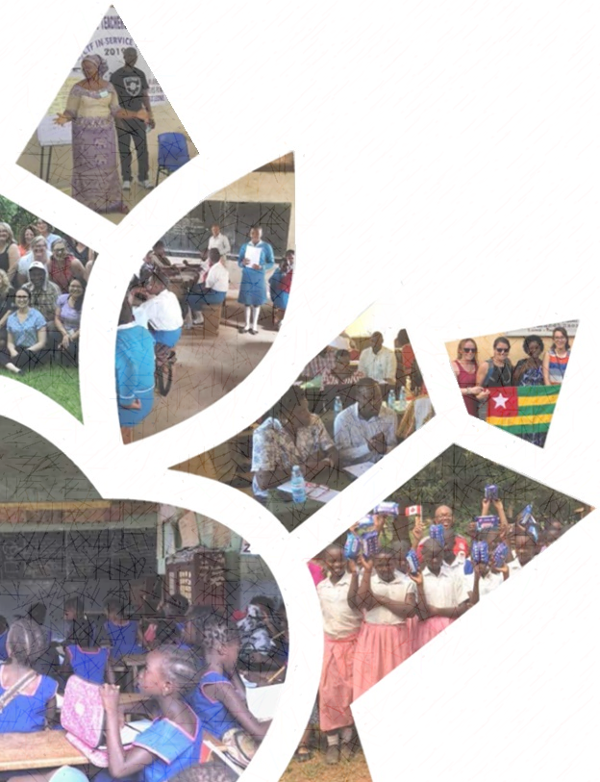
CRITERIA FOR APPLICATION
Applications are welcome from any Canadian teacher who:
- is a Canadian citizen;
- holds a Canadian passport valid until at least July 2025, at the time of application (proof that a passport application has been made will be accepted);
- is a member of a provincial or territorial teacher
organization that supports PO;
- holds a valid teaching certificate;
- has completed at least five years of teaching in
Canada by July 2024;
- is in excellent health and be able to work in
developing country conditions;
- has high standards of professionalism and
personal conduct;
- shows evidence of flexibility and mature judgment;
- is willing to put the team and project needs above personal needs.

HOW TO APPLY
Teachers wishing to apply for Project Overseas can obtain application forms and additional information from their sponsoring provincial/territorial teacher organization.
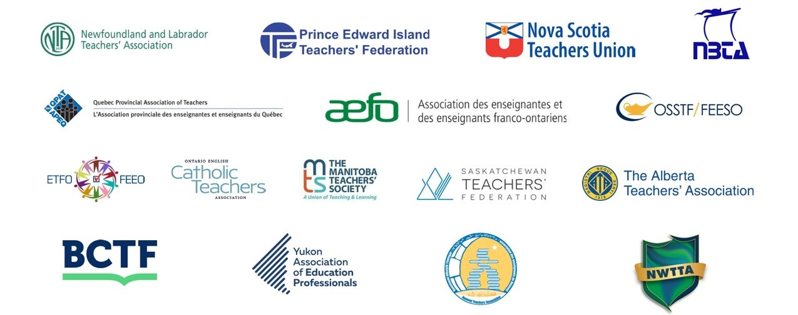
Sponsoring Member Organizations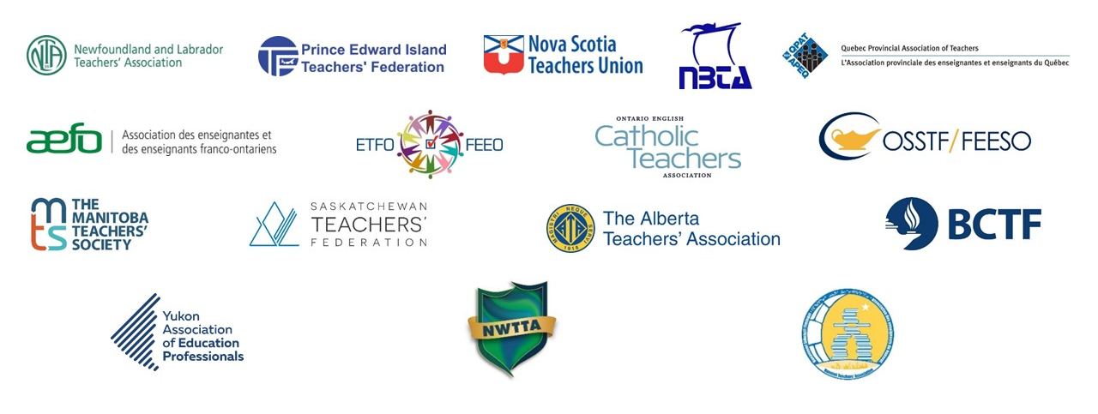

Founded in 1920, the CTF/FCE is a federation of teacher organizations in every province and territory of Canada and is an active member of Education International. We promote and support quality inclusive publicly funded public education in all its forms. We uphold teaching as a profession and advocate for adequate resourcing, labour rights, and social justice across Canada and around the world.

